**SHIPPING COST PROGRAM**

Automation and Digitalization of Shipping Cost Calculations to Provide Accurate Data and Speed Up the Evaluation Process of the Distribution Mode

This program was designed to do any calculation related to the shipping cost of Supply Chain Department, effortlessly and automatically, with zero human error. With the cost of implementing the program that only 28mio IDR, we could obtain net quality income (NQI) in the first year of (approx.) 151mio IDR and also save at least three additional manpower.

**DEFINE THE PROBLEM (MENENTUKAN PERSOALAN/TEMA)**

Speaking generally, there are three major steps in the Transportation Section of Supply Chain Department of PT Astra Otoparts Tbk, which are planning (vendor selection), operation (ordering fleets, loading & delivery, billing, payment), and evaluation (evaluating the process). The increase in vendor payment recently made us have to take a closer look at the evaluation process to maintain our KPI (shipping cost less than 1.5% of sales and cost reduction program). But, as we go deeper in the evaluation process, the more it gets complicated because there are many parameters when calculating the shipping cost.

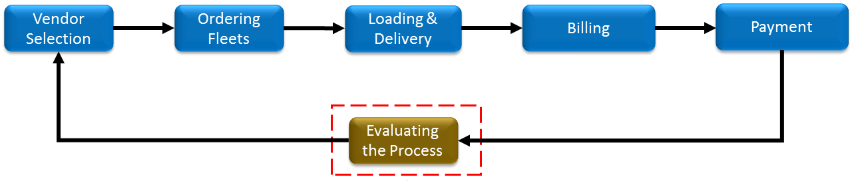

For the record, our Central Distribution Center (CDC) in Cibitung, Bekasi operates six days a week and dispatches up to 60 fleets daily. One single fleet could cover more than one sales office, deliver up to 25 stores, with more than one sales-type and multiple product-groups for each store. In order to evaluate the whole process, we need to know the cost needed to serve each sales office, each sales-type, and each product-groups. At first, we tried to manually calculate and break down the shipping cost of a single fleet, turns out it takes up to 20 minutes to finish.



As you can see from the projection above, we need approximately 500 hours only to calculate the shipping cost for a month (not including the other evaluation process), which is impossible to be done by one employee, we need at least two or three additional employees. Meanwhile, the planning process takes only 80 minutes per month, and the operation process needs only 62 minutes per month, as you can see in the pareto diagram below.

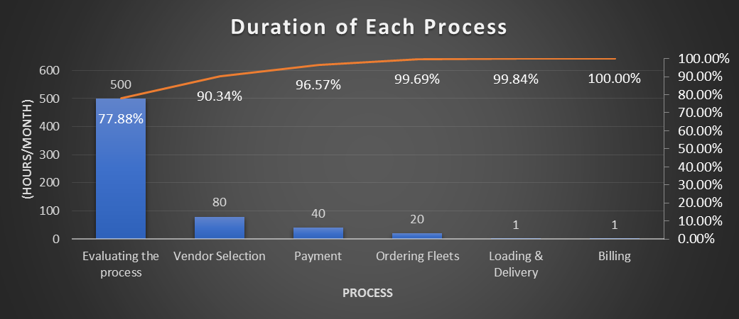

We came to an agreement that adding three additional employees only to calculate shipping cost is a waste, especially during the pandemic COVID-19, and it should be done automatically by a computer program for the sake of accuracy and rapidity. Therefore, we decided to improve the shipping cost calculation process and this time the topic is “Automation and Digitalization of Shipping Cost Calculations to Provide Accurate Data and Speed Up the Evaluation Process of the Distribution Mode”.

**DEFINE THE GOALS (MENETAPKAN TARGET)**

After long consideration, we decided that the ideal time needed to do the calculation is only 50 hours per month. Hence, we agree that the goal is lowering the time needed to calculate shipping cost by at least 90%.

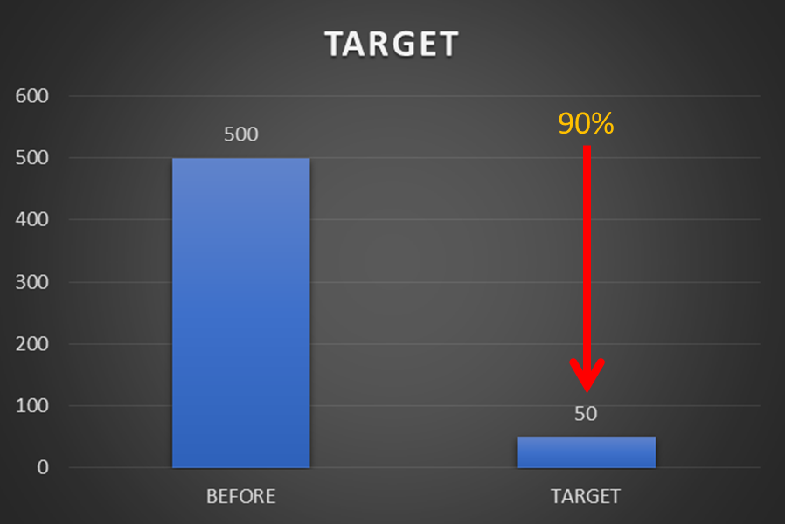

To define the goal of our improvement, we utilize S.M.A.R.T. criteria to guide us in determining the targets that “Specific”, “Measurable”, “Achievable”, “Realistic”, and “Time-based”.

**S**pecific : to focus on improving the shipping cost calculation process

**M**easurable : decreasing at least 90% time needed

**A**chievable : can be achieved with a well-considered and fully review design

**R**ealistic : by changing the manual process with the help of a computer program

**T**ime-based : well-targeted to finished by the end of January 2021



We also aim to impact the QCDSMPE (Quality, Cost, Delivery, Safety, Morale, Productivity, Environment). As for the **Quality**, the calculation by a computer program will give us a 100% guarantee of accuracy. As for the **Cost**, this improvement will save us from unnecessary additional employees. As for the **Delivery**, this program will deliver the calculation we needed at least 90% faster than done manually. As for **Morale**, this improvement could increase awareness of cost-efficiency. The rest will not be stated, for there is no impact on it.

**ANALYZE THE CURRENT SITUATION (ANALISA KONDISI YANG ADA, ANAKONDA)**

To analyze the current situation, we adopt Genba, Genchi, Genbutsu principles by taking a detailed look at the actual condition and compare it to the ideal condition. Here is what we found in a 4M+1E analysis.



**ANALYZE THE ROOT CAUSE OF THE PROBLEM (ANALISA SEBAB AKIBAT, ANASEBA)**

To analyze the root cause of the problem, we are simply using fishbone diagram as you can see below.

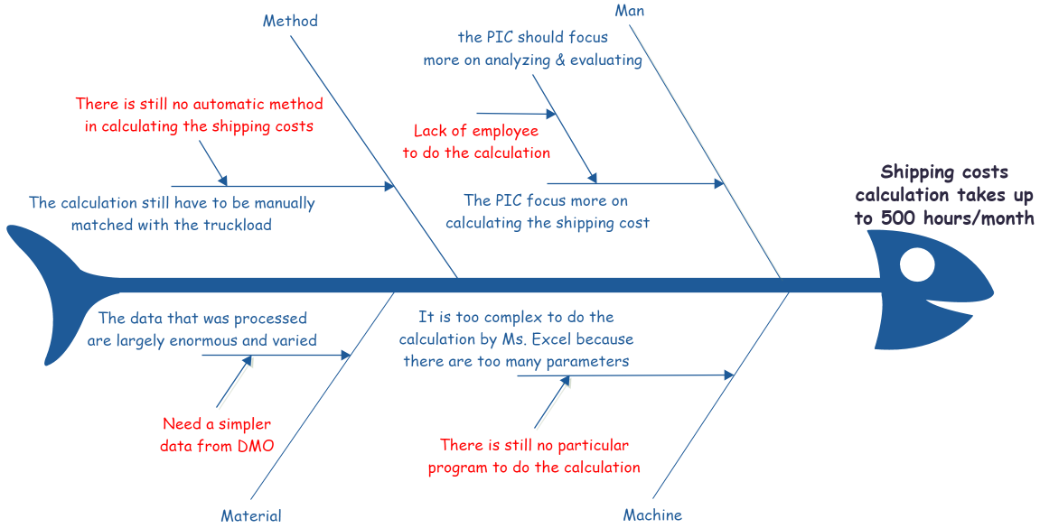

**DEVELOP ACTION PLAN (MERENCANAKAN PENANGGULANGAN)**

After we got the root cause of the problems, we are using 5W+2H approach to develop action plan.



**EXECUTE ACTION PLAN (MELAKSANAKAN PENANGGULANGAN)**

As I said earlier, I need to know the cost needed to serve each sales office, each sales-type, and each product-groups to calculate the shipping cost. Those data are available in WMOS (warehouse core system), but it would take a long query since those data are not in the same table. That’s why I recommend collecting those data from Checksheet Digital Report in DMO (warehouse support system), where the program can collect the data from a single table and automatically match the actual data of the truckload.

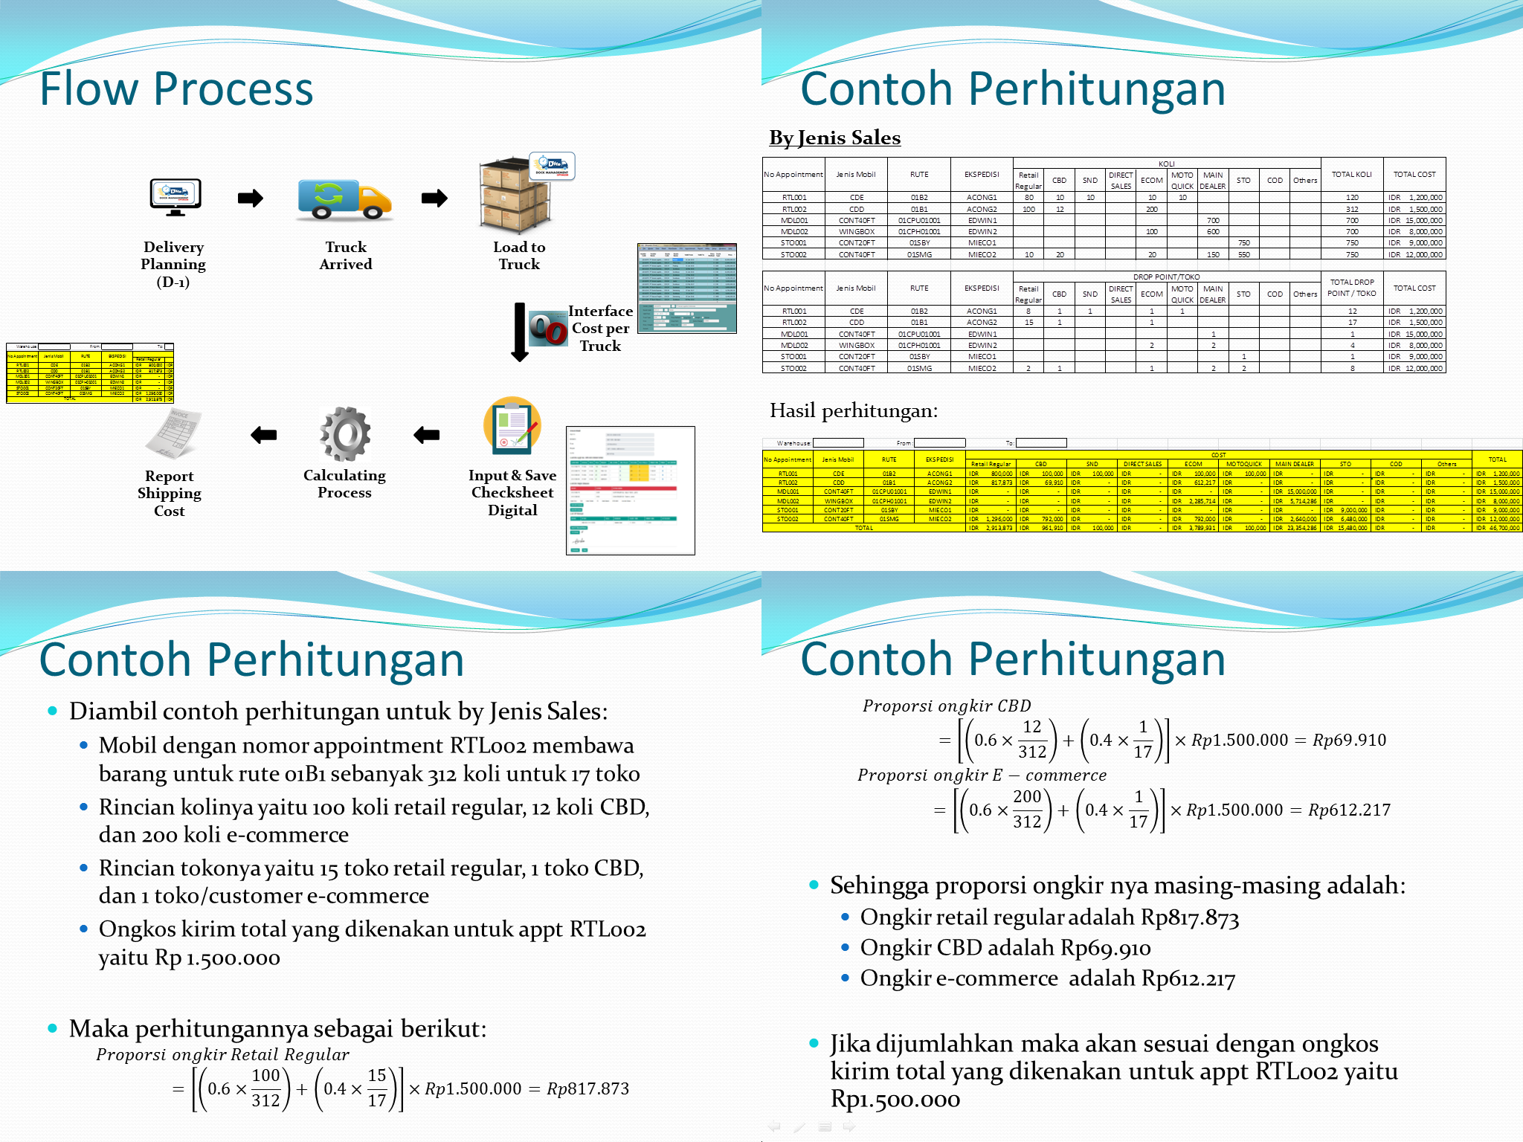

Although it’s already faster to collect the data, it still needs a large number of resources (processor, RAM, etc) to process and calculate the data the way I wanted, so again I suggest that the calculation can be done not at the client-side but at the server-side, and automatically at 3 AM every next day. Therefore, the report will be ready to use every day in the morning, without having to wait for any calculation processes.

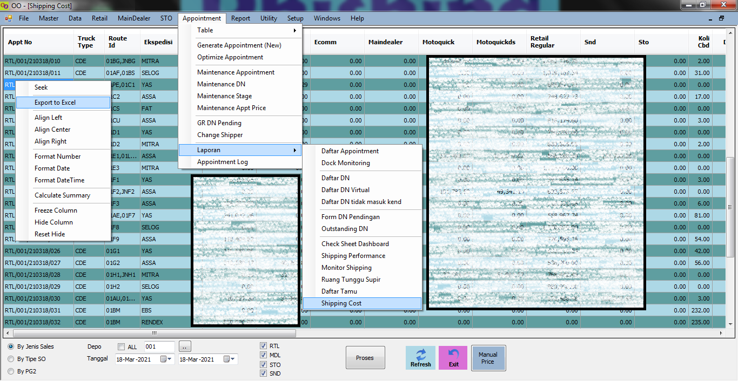

Here is the snipping of the Shipping Cost Program (some data cannot be showed). You can see that there are many features and filters to enhance the output. The “Proses” button is a command button to request re-calculate any selected date if necessary. It is also possible to manually overwrite the tariff of the selected fleet with the “Manual Price” button, again, if necessary.

**EVALUATE THE RESULTS (EVALUASI HASIL)**

After implementing the action plan, we did some tests again and found out that we don't need to do the previous activity list anymore. Instead, some new activities require to be done. The time needed to calculate the shipping cost is also significantly reduced by 99.8% from 500 hours to only 1 hour per month, which means we exceeded the target. We tried to forecast how much cost we could save in the first year, it turns out the net quality income is Rp151.334.757,96. For information, we did the calculation by using minimum wage of Bekasi District in 2021 (UMK Kab. Bekasi 2021) which is Rp4.791.843,90 per month. Did not forget to mention that we managed to meet our target at QCDSMPE aspect. Here are the details.





**CONTINUOUSLY IMPROVE (STANDARISASI DAN LANGKAH SELANJUTNYA)**

We're all well aware that improvement is a continuous activity, and that's why we cannot stop here. The employees might shift or change, but this system should preserve. So we have to make a work instruction (WI) or standard operation procedure (SOP), in this case, a manual-book to completely guide anyone to operate the Shipping Cost Program.

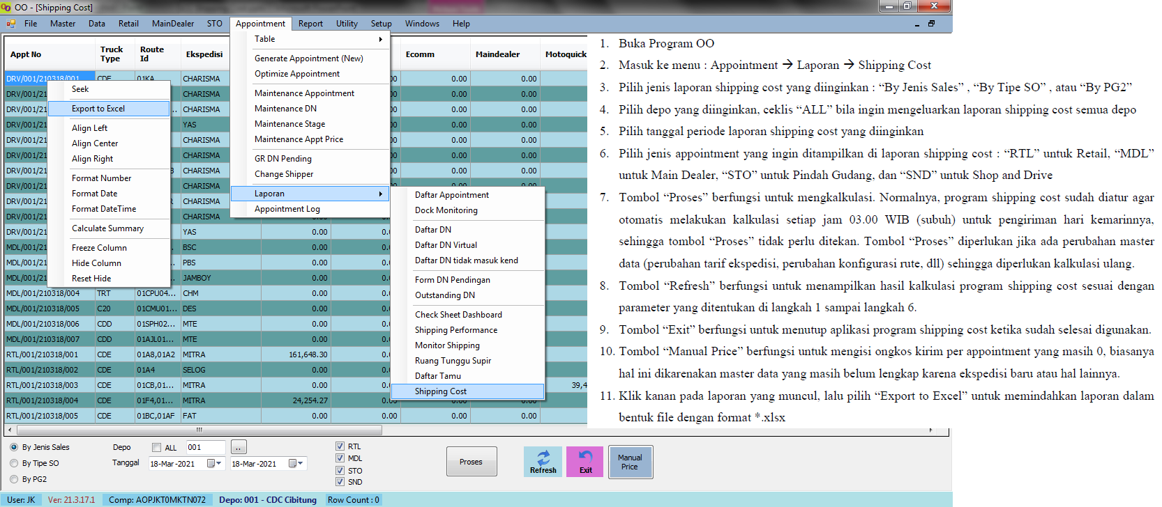

After three months trial, we decided to do the yokoten process. We managed to implement the program not only at the CDC, but also at the RDC (Regional Distribution Center) Surabaya, RDC Bandung, and RDC Semarang. As I write this article, we are attempting to implement this program at the DC (Distribution Center) Serang, DC Jember, DC Denpasar, DC Purwokerto, and DC Manado.